Executive Summary
Previously at Stellen, an event management platform whose organizational customers manage hundreds of shared operational credentials, I helped design GroupSecret, a feature that let event teams share credentials with role-based access and audit. For this onboarding exercise, I rebuilt the GroupSecret as Team Vault on AWS: Cognito Hosted UI with PKCE, CloudFront/S3, API Gateway with a Cognito authorizer, Lambda, DynamoDB, KMS envelope encryption, CloudTrail audit, and IAM Access Analyzer checks.
The build surfaced a recurring IAM pattern: AWS usually had the right control, but the product did not always show which control to use, where to configure it, or what to check next. This report explains the Team Vault build, stack-ranks the top 10 IAM friction points together with some corresponding product opportunities.
What is the build context?
The build uses a customer scenario I saw at Stellen: a team needs to share operational credentials, including payment API keys, observability tokens, customer-specific keys, and CI/CD signing keys. A customer contract bars storing payment-flow credentials in third-party SaaS, so the team builds the vault inside its own AWS account.
This scenario creates a real IAM use case because the vault requires Cognito, KMS, DynamoDB, API Gateway, CloudFront, CDK, and IAM Access Analyzer to work together in one customer workflow. Each service exposes its own IAM surface, and the 29 friction observations in this report come from composing those surfaces into a working application.
What does Team Vault do?
Team Vault is a single-tenant AWS-hosted credential manager for teams that need shared secrets, role-based access, encryption, and audit inside their own AWS account. Admins can create, reveal, delete, audit, and invite members. Members can list and reveal secrets. Self-signup is disabled; access is invite-only through Cognito admin APIs.
The security model uses KMS envelope encryption and two audit layers. Lambda calls GenerateDataKey on write, encrypts the secret locally with AES-256-GCM, and stores ciphertext plus the encrypted data key in DynamoDB. On reveal, Lambda calls Decrypt and returns plaintext for a single request. DynamoDB records application audit events, and CloudTrail separately records KMS key use.
How is Team Vault built?
- Account guardrails. Enable root MFA, configure a low-spend budget alarm, enable IAM Identity Center, choose a permanent home region, and stand up admin access through the SSO CLI.
- Infrastructure-as-Code. Install AWS CDK, run cdk bootstrap once per region, inspect the IAM roles it creates, and deploy a hello-world Lambda behind API Gateway.
- End-user authentication. Stand up a Cognito user pool, enable the Hosted UI, attach a Cognito authorizer to API Gateway, and verify that ID tokens reach Lambda as claims.
- Scoped storage. Introduce DynamoDB with a single-table design. Read and write secrets scoped first by user identity, later refactored to team identity.
- Envelope encryption. Create a customer-managed KMS key with annual rotation. Switch the handler to GenerateDataKey on write and Decrypt on read so plaintext exists only in Lambda memory during a single request.
- Web frontend. Build a Vite + React SPA. Host it on a private S3 bucket served through CloudFront with Origin Access Control. Wire OAuth to Cognito's Hosted UI with PKCE.
- Roles, audit, and invitation. Create Cognito groups (vault-admin, vault-member) for roles. Gate sensitive endpoints on the cognito:groups claim. Add audit-log, delete, and member-invitation endpoints.
- Policy validation. Run IAM Access Analyzer's validate-policy, check-no-public-access, and unused-access analysis against the deployed policies and test policies to compare what each tool catches.

What are the top IAM friction points?
# | Friction point | Why it matters | Product suggestion
1 | validate-policy did not route a Principal: "*" trust policy to check-no-public-access. AWS has the detection capability, but it lives in a separate command. | The pre-deploy validation path returns no findings on a high-impact misconfiguration. The customer must already know check-no-public-access exists to find it. Risky policies move downstream to review, support, or production. | Have validate-policy fan out to the specialized public-access check when resource type is known, or return a next-step hint naming check-no-public-access and external-access analysis.
2 | KMS access depends on both key policy and identity policy, but the default root statement silently enables IAM delegation. | Teams adopting encryption misdiagnose access failures, over-grant to get unstuck, or avoid customer-managed keys. The "double grant" contract is real but the default makes it invisible. | Label the root statement as "enables IAM policy delegation" in console, CDK output, and error messages. Add a preflight check that names which side of the contract is missing.
3 | API Gateway CORS has three independent configuration surfaces: preflight, Lambda response, and gateway responses for 401/403. | All three failures collapse into the same browser Failed to fetch error, so engineers debug frontend, auth, and API layers without knowing which one failed. The third surface only fails after token expiry, often hours later. | Provide one API-level corsContract property for Cognito-protected APIs that applies to all three surfaces. As a minimum, a CDK synth warning when preflight is configured but gateway responses are not.
4 | DynamoDB LeadingKeys promises per-row IAM enforcement, but the Lambda execution-role pattern collapses all users to one principal. | Per-user IAM row scoping requires sts:AssumeRole with session tags, which most teams skip. The result: app-only authorization even when IAM has a marquee condition-key primitive for exactly this case. | Publish a first-class CDK construct (e.g., ScopedDynamoTable) for Lambda plus DynamoDB scoped access, with session-tag propagation, sample policies, and failure-mode tests. Alternative: extend API Gateway's Cognito authorizer to pass cognito:sub as a session tag automatically.
5 | cdk bootstrap silently creates five IAM roles plus supporting resources. | The first infrastructure step feels like hidden permission expansion. Trust and pass-role chains are invisible to the user; regulated teams escalate this to security review. | Print a purpose table for each role/resource before creation. After creation, add cdk bootstrap --show-resources for post-hoc inspection.
6 | CDK's default cfn-exec-role carries AdministratorAccess. | The deploy path (user → deploy role → CloudFormation → admin execution role) is not taught at the consent moment. Regulated teams block CDK adoption if the default appears to require account-wide admin. | Offer a guided least-privilege bootstrap profile for common app shapes. Explain the deploy-role-to-execution-role chain in cdk deploy output.
7 | CDK's IAM change prompt lists statements uniformly — routine plumbing and broad grants look equally opaque. | Customers learn to approve IAM changes they cannot evaluate, undermining the prompt's security goal. The pattern likely produces more silent overgrant than informed consent. | Add plain-language annotations, a blast-radius summary, and a "new broad permissions" callout before the y/n prompt.
8 | IAM Identity Center home region is permanent, but the enablement screen does not say so. | Region choice happens early, before customers understand permanence. The newer multi-region feature can be misread as making the home region mutable. Mistake requires a new account. | Put the permanence warning on the enablement screen. Distinguish replication from home-region mutability in console copy and docs.
9 | Cognito group changes require token refresh — the newly-assigned cognito:groups claim is invisible until re-authentication. | API Gateway authorizer caching can extend the gap further. Admins debug confusing 403s as IAM or API defects when the cause is token staleness. | State the re-authentication requirement in Cognito console and AdminAddUserToGroup docs. In API Gateway, warn when authorizer caching may delay permission changes after a group change.
10 | API Gateway's Cognito authorizer accepts ID tokens but rejects access tokens — opposite of OAuth 2.0 convention. | Wrong-token, expired-token, and malformed-token failures all return generic 401s, so customers debug the wrong layer. This is a common newcomer gotcha that contradicts OAuth intuition. | Differentiate wrong token type, expired token, and malformed token in authorizer responses. Include a one-line link to the expected token type for API Gateway.

What are the product opportunities?
The pattern across these observations is not that IAM lacks controls. In most cases, the control exists. The opportunity is to surface the right control, setting, or validation step at the moment the customer is making the security decision.
- Surface AWS-created IAM surface when AWS creates it. Bootstrap roles, KMS defaults, Identity Center setup, and `cdk deploy` prompts should show newly created or newly expanded permissions with purpose labels. This would make hidden trust boundaries visible earlier and reduce security-review back-and-forth.
- Collapse cross-service contracts into guided patterns. CORS, KMS grants, Cognito authorizers, and DynamoDB row scoping each require configuration across services. Higher-level CDK patterns and console guidance would reduce setup time for common customer architectures and lower support burden.
- Turn machine errors into next-step actions. Wrong token type, stale Cognito group claims, missing CORS on gateway responses, and KMS policy-side failures should name the failing layer and the next action. This would convert generic access failures into self-service recovery instead of support cases.
- Route customers across the Access Analyzer tool surface. `validate-policy`, `check-no-public-access`, and unused-access analysis answer different questions. Access Analyzer should guide customers from one surface to the adjacent one when the current tool cannot answer the customer’s real question.

Appendices
Appendix A: Links and demo access
- Live demo at https://d27nvg04sp0g9m.cloudfront.net/
- Code repo at https://github.com/cheers-nl/iam

Appendix B: 29 IAM friction observations logged during the build
- Root MFA banner said "required in 33 days" without explaining what enforcement meant.
- IAM and IAM Identity Center appeared side by side with names that did not explain the difference.
- IAM "policies" and Identity Center "permission sets" used different names for related concepts.
- aws configure sso asked for an SSO session name without inline help.
- The SSO browser flow landed on the access portal instead of completing the CLI device authorization.
- The SSO browser flow did not explain that it needed Identity Center credentials, not root credentials.
- Identity Center setup did not signal that CLI configuration was a separate next step.
- cdk bootstrap created five IAM roles and supporting resources without a consent summary. (→ Top 10 #5)
- The Bedrock-backed advisor I prototyped flagged a prompt-injection Sid as an indicator of compromise; validate-policy treated the same value as inert text.
- Cognito group changes required re-authentication before new claims appeared. (→ Top 10 #9)
- The cognito:groups claim appeared as different shapes across paths, forcing defensive parsing in authorization code.
- AdminCreateUser plus AdminAddUserToGroup created a non-atomic invitation flow with orphan-user risk.
- validate-policy missed overprovisioning that unused-access analysis later flagged.
- validate-policy gave misleading trust-policy errors unless the resource-type hint was known.
- validate-policy did not route public-principal trust policies to check-no-public-access. (→ Top 10 #1)
- Unused Access Analyzer was fast and useful, and independently validated CDK bootstrap overprovisioning.
- CDK half-abstracted CORS: preflight lived in stack config while response headers lived in Lambda code.
- API Gateway CORS had three independent surfaces, including gateway responses for generated 401/403s. (→ Top 10 #3)
- KMS access required key-policy and identity-policy alignment, but the default delegation rule hid the relationship. (→ Top 10 #2)
- KMS access-denied errors named the failing side but did not hint at the other side of the contract.
- CDK's grantEncryptDecrypt added more KMS actions than the Lambda used.
- aws kms get-key-policy rejected key aliases, unlike other KMS commands that accept aliases.
- CDK's grantReadWriteData() expanded to twelve DynamoDB actions for an app that needed three.
- DynamoDB LeadingKeys promised row-level IAM enforcement but was hard to wire through Lambda backends. (→ Top 10 #4)
- API Gateway's Cognito authorizer accepted ID tokens but rejected access tokens. (→ Top 10 #10)
- cdk deploy IAM statement changes asked for consent a newcomer could not meaningfully evaluate. (→ Top 10 #7)
- CDK's cfn-exec-role carried AdministratorAccess by default. (→ Top 10 #6)
- Fresh cdk init emitted deprecated dependency and Node warnings.
- Identity Center home region was permanent, but the setup flow did not make that clear. (→ Top 10 #8)

Appendix C: Team Vault demo walkthrough
The 8 figures below walk through the live demo: identity layer (PKCE login), role-based access (admin vs member views), envelope encryption (reveal + audit), the security model for unassigned users, and the 2 independent layers of audit (application log + CloudTrail).
Figure 1 — Real-world orgin of Team Vault
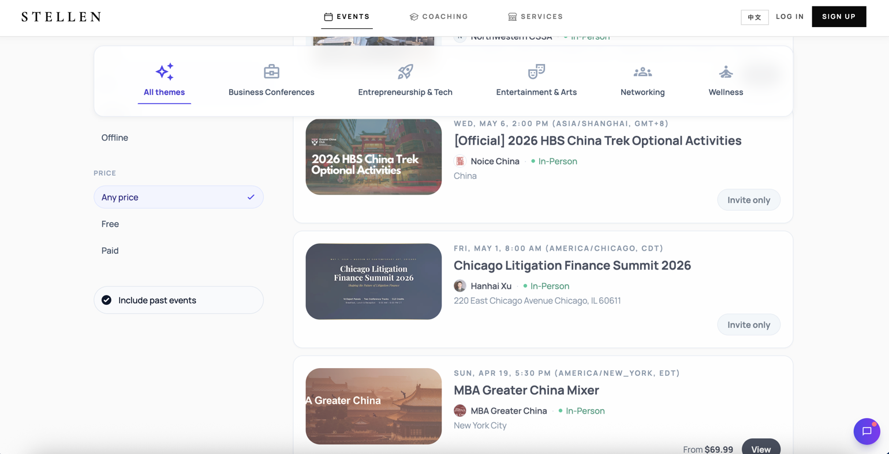
Stellen is the event management platform whose GroupSecret feature is the direct ancestor of Team Vault. The customer scenario described in this report — organizational teams sharing dozens of operational credentials with role-based access and audit — is the same problem Stellen's customers asked GroupSecret to solve. Team Vault is that problem rebuilt on AWS-native primitives.
Figure 2 — Cognito Hosted UI with PKCE-protected authorization-code flow
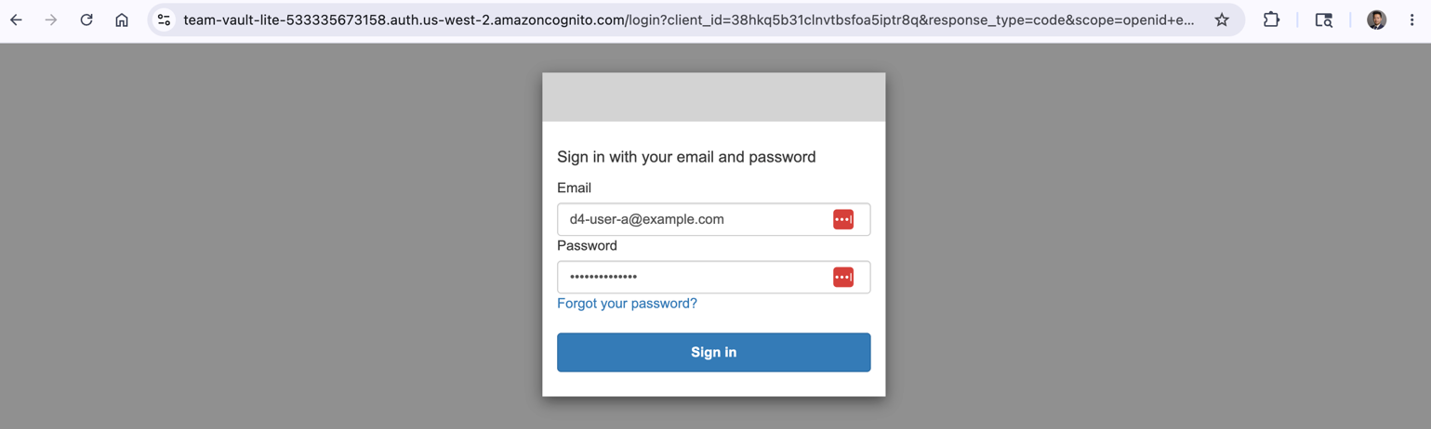
The login page issued by Amazon Cognito's Hosted UI. The address bar shows the PKCE parameters (code_challenge, code_challenge_method=S256), which is the OAuth 2.1 baseline for public SPAs and the auth primitive Top 10 #10 builds on.
Figure 3 — Vault list as a vault-admin
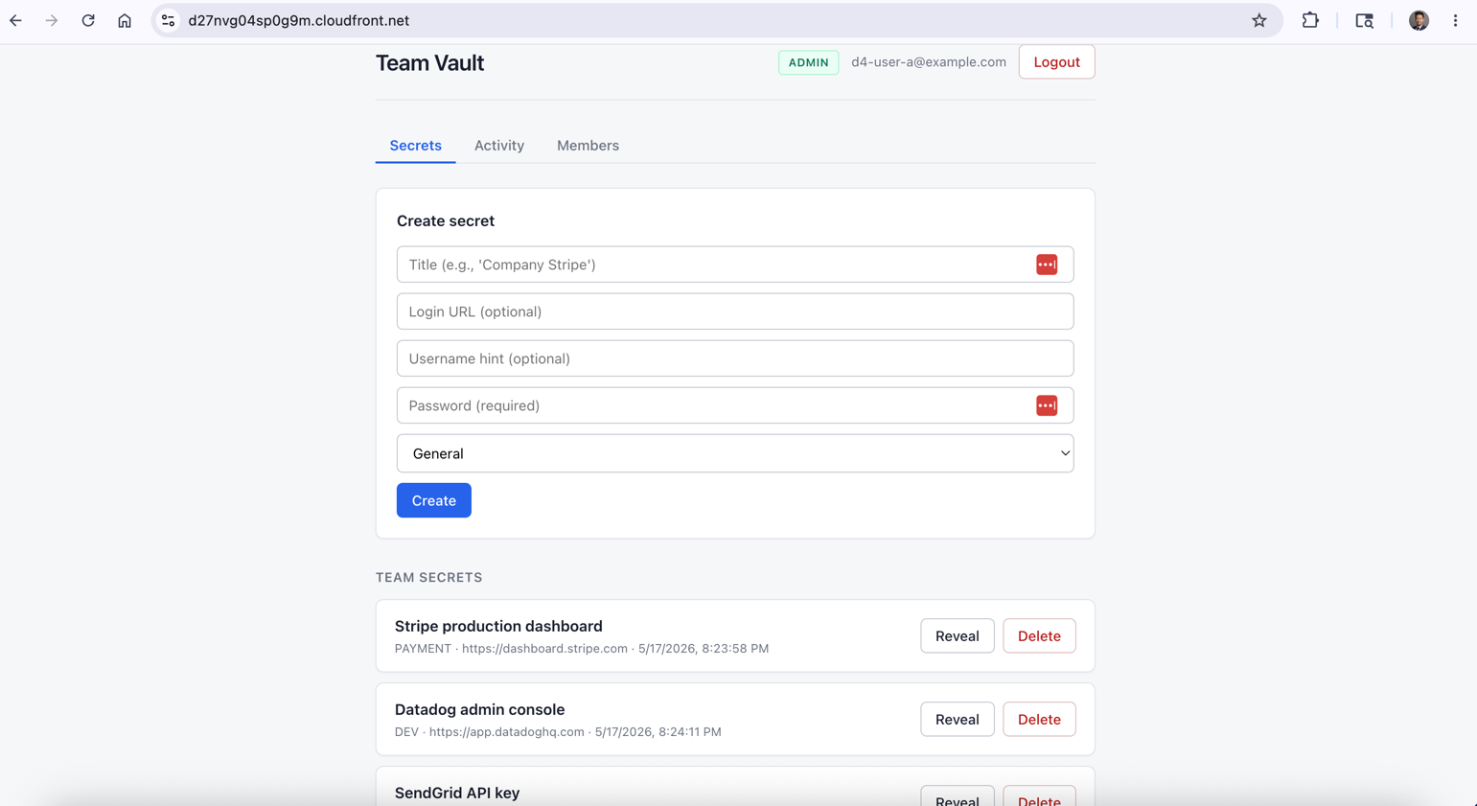
After signing in as an admin, the SPA renders the full management surface — list, reveal, create, delete, audit, and invite. The UI gates on the cognito:groups ID-token claim and surfaces every action available to that role.
Figure 4 — Reveal of a secret value
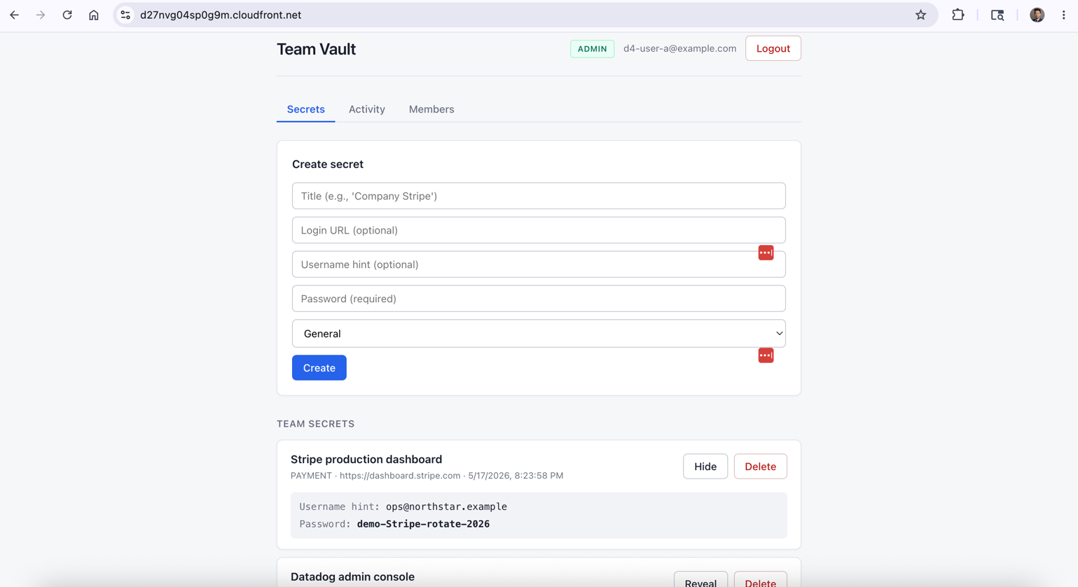 Clicking Reveal triggers the envelope-decryption flow: Lambda calls KMS.Decrypt with the stored encrypted data key, uses the resulting data key to AES-256-GCM-decrypt the ciphertext from DynamoDB, and returns the plaintext for a single request. Plaintext never sits in storage and only lives in Lambda memory for the duration of the call.
Figure 5 — The same reveal alongside the application audit log
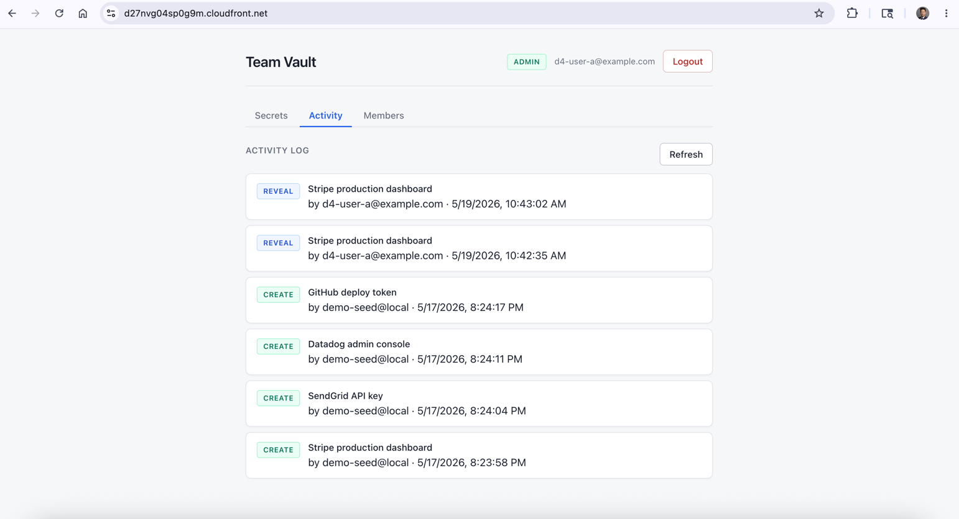
Each reveal writes an AUDIT row to DynamoDB with the actor email, actor Cognito sub, secret ID, and a millisecond-precision timestamp. This is the first of two independent audit layers (see Figures 7 and 8).
Figure 6 — Vault list as a vault-member
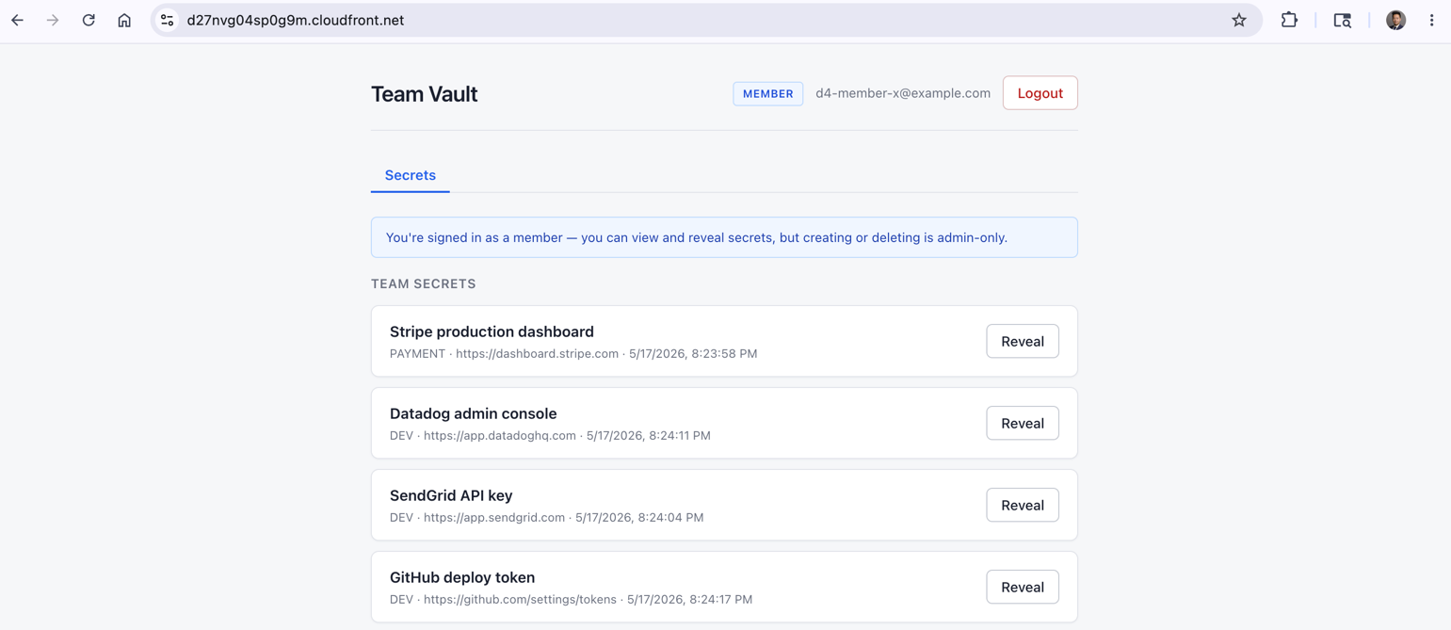
The same application rendered for a non-admin. The member can list and reveal, but create / delete / audit / invite are absent from the UI. The backend Lambda also enforces the role check on every endpoint independently of the UI — the UI gate is convenience, not security.
Figure 7 — Pending vault access for an authenticated user with no group
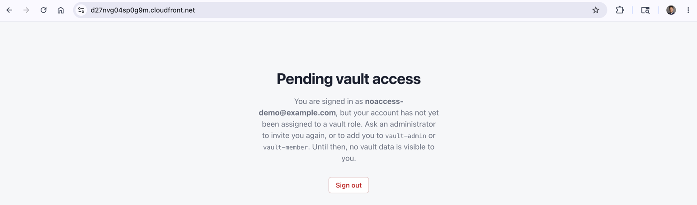 A user can complete Cognito sign-in but if they are not assigned to either vault-admin or vault-member, the SPA shows this page and the Lambda returns 403 on every vault endpoint. This is the deny-by-default posture introduced in the D8 hardening pass and the visual evidence that the P0 authorization gap is closed.
Figure 8 — Application audit row in DynamoDB
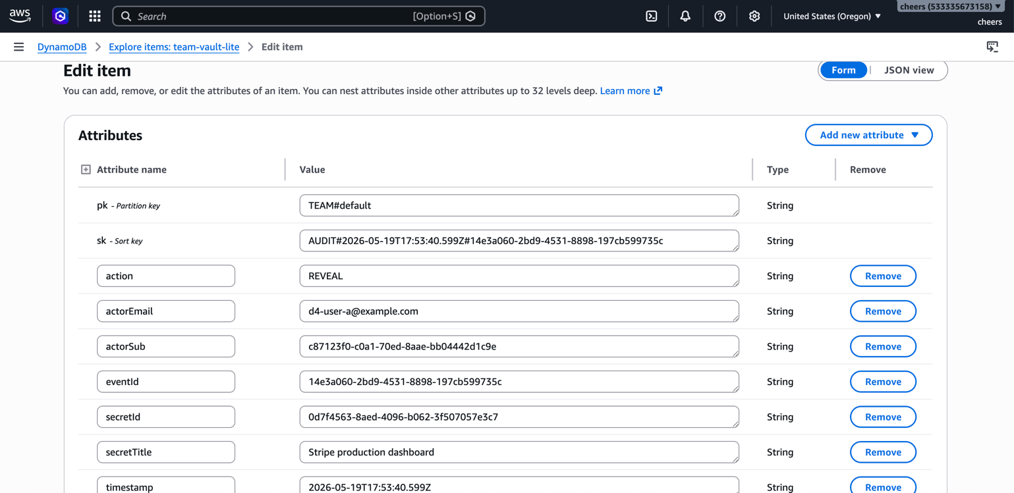
The AUDIT item written by the Lambda during the reveal in Figure 4. actorEmail, secretId, and timestamp (2026-05-19T17:53:40.599Z, UTC) identify the operation. This is the application's record of who revealed what, when.
Figure 9 — Corresponding CloudTrail KMS Decrypt event
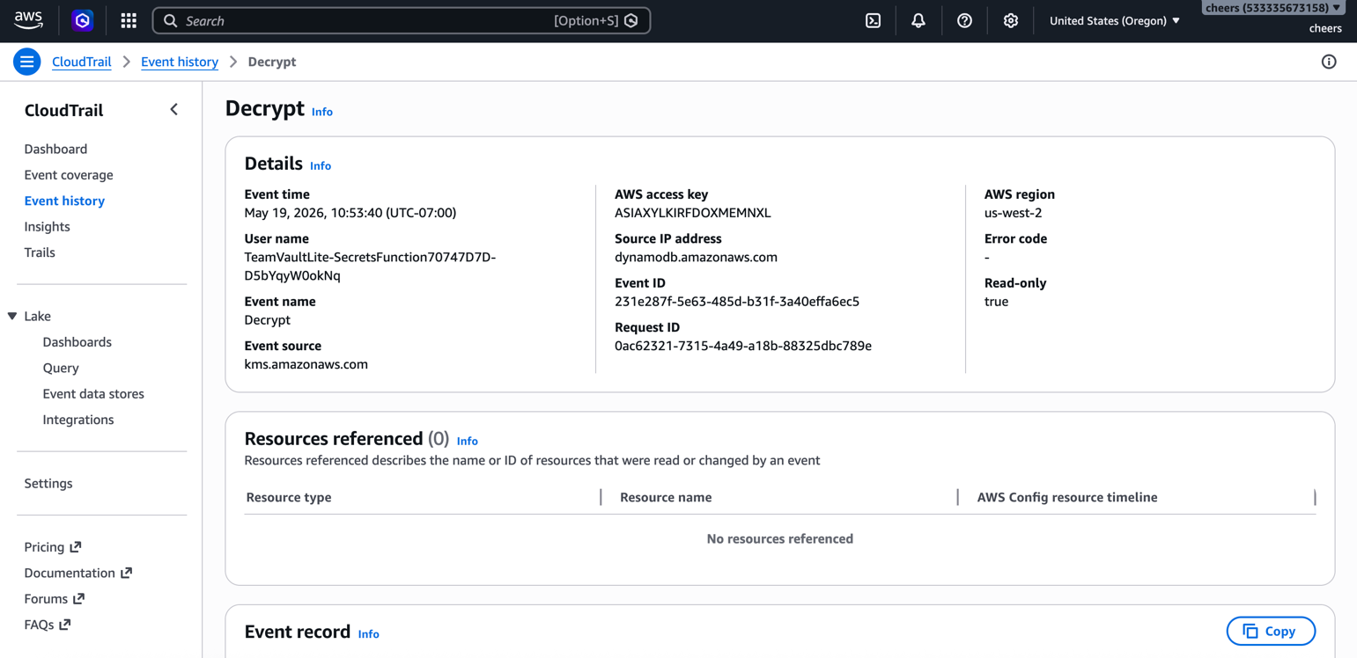
The same operation captured by AWS CloudTrail at the infrastructure layer. The User name is the Lambda execution role, the Event time is 10:53:40 PT (17:53:40 UTC — the same instant as Figure 7 to the millisecond), and the event was written by AWS independent of the application. The two layers correlate by timestamp and principal but have independent event IDs by design — that independence is what makes the audit tamper-evident: an attacker who erased the DynamoDB row in Figure 7 could not remove this CloudTrail event.

